Name

Shilpa G Gondi

SOMAKKA PUJAR

Swati R Bailannanavar

SANGEETA BELAVATTI

Ashwini k tippigunder

KEERTHI E

Nikhil Banne

TEJASHWINI MANJUNATH MALLUR

Manjunath Bailaseemi

Vidya Y Matanavar

Pooja Pujar

Pruthvi kashetti

Kavita C Hiregoudra

Daneshwari S Bilekudari

Suchita P Pawar

NAGALAXMI BEVINAMARAD

Kavya S Baraker

Shivani NM

Sabiha Shaikh

Vidya Guddikoppa

Shridevi Panagal

Spoorthy Keshav Nayak

Seema A Tilavalli

Kavana sagar

Divya Sutar

Akshata,Honnappa,lenkemmanavar

Amruta Hirematha

PAVITRA HIRUR

Annapoorna Rajendra Sunagar

Krishna naganoor

Arbiya Banu S Devihosur

Madhu Hosamani

POOJA ALLAPUR

VISHVANATH

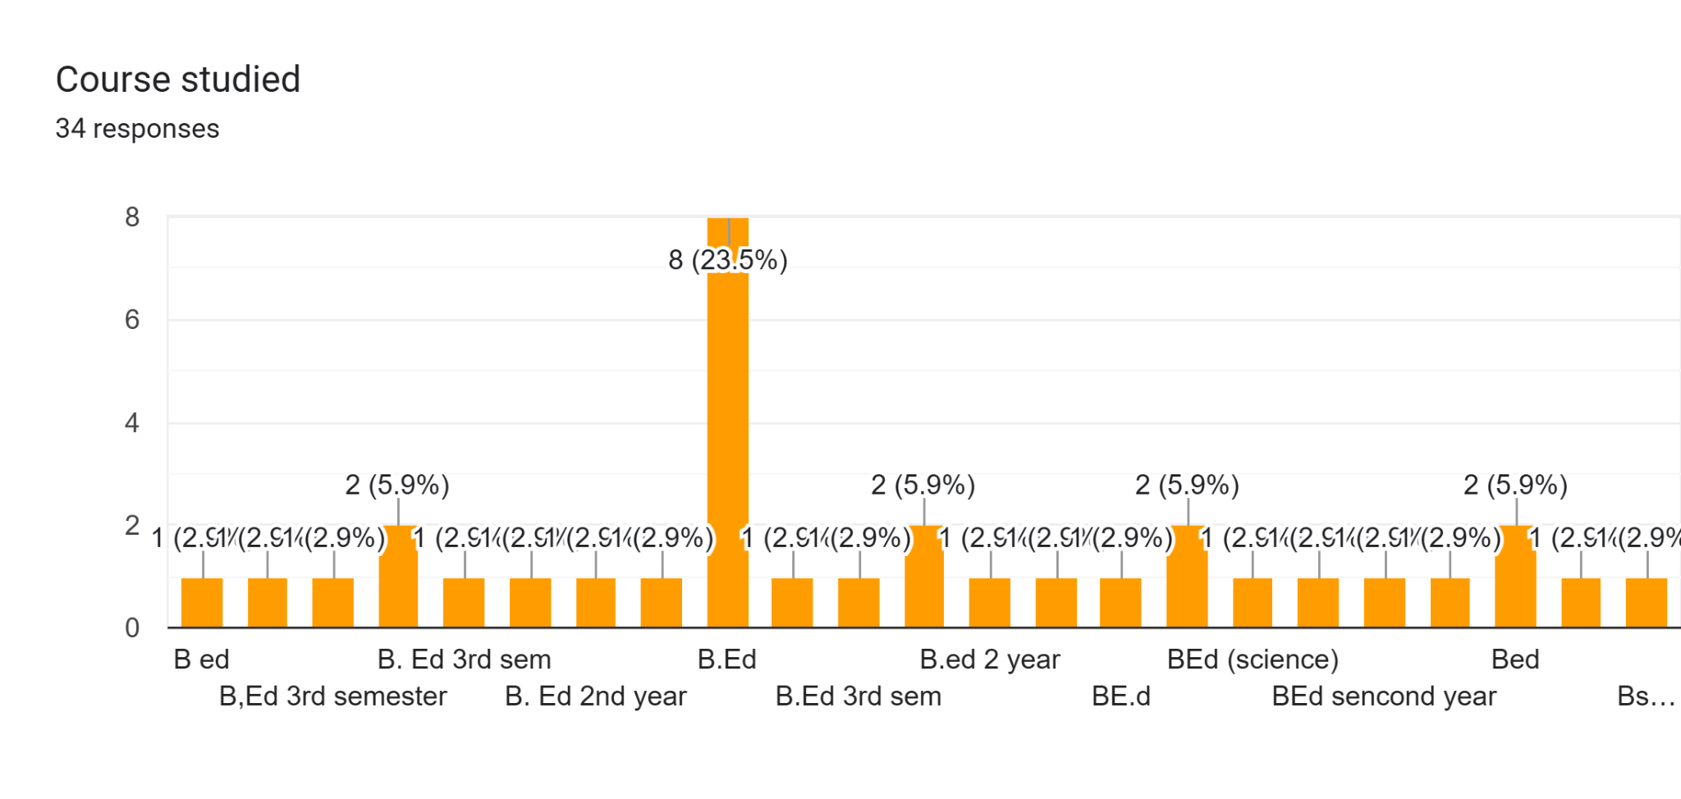

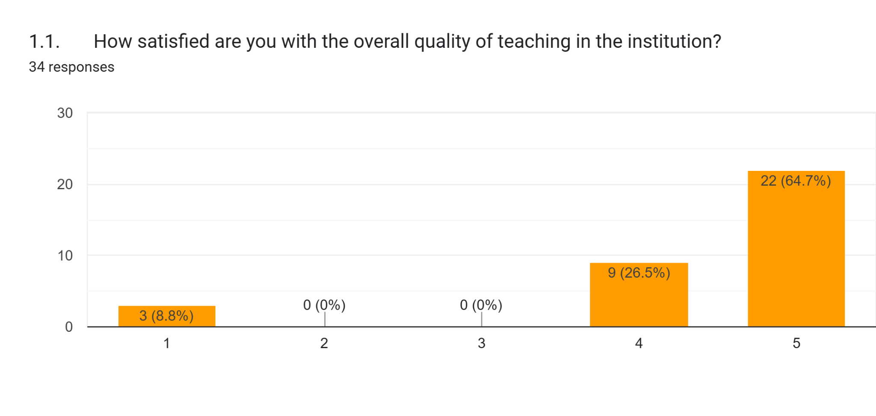

Forms response chart. Question title: 2.How would you rate the support provided by faculty members for your academic progress?
. Number of responses: 34 responses.

